

*Russian Cat Interest Group of SA*

*BLUE. BLACK. WHITE. BLUE SPOTTED TABBY.*



**CFC Show Gauteng 6th & 7th June 2015**

**The CFC Cat Show was held up in Gauteng on the 6th & 7th June, with four Russians entered.**

**On Saturday Mila, Whimsy and Brie were on show and on Sunday Brie and her brother Bagheera were on show. Needless to say the judges where impressed with the new generation of Russians that make it to the show bench, but again, not enough Russians are shown in South Africa and we urge the Russian Pet Homes to PLEASE PLEASE enter cat shows and get the Russians exhibited and shown off.**

**On Saturday Brie got such amazing kitten reports from two judges which I would like to share here.**

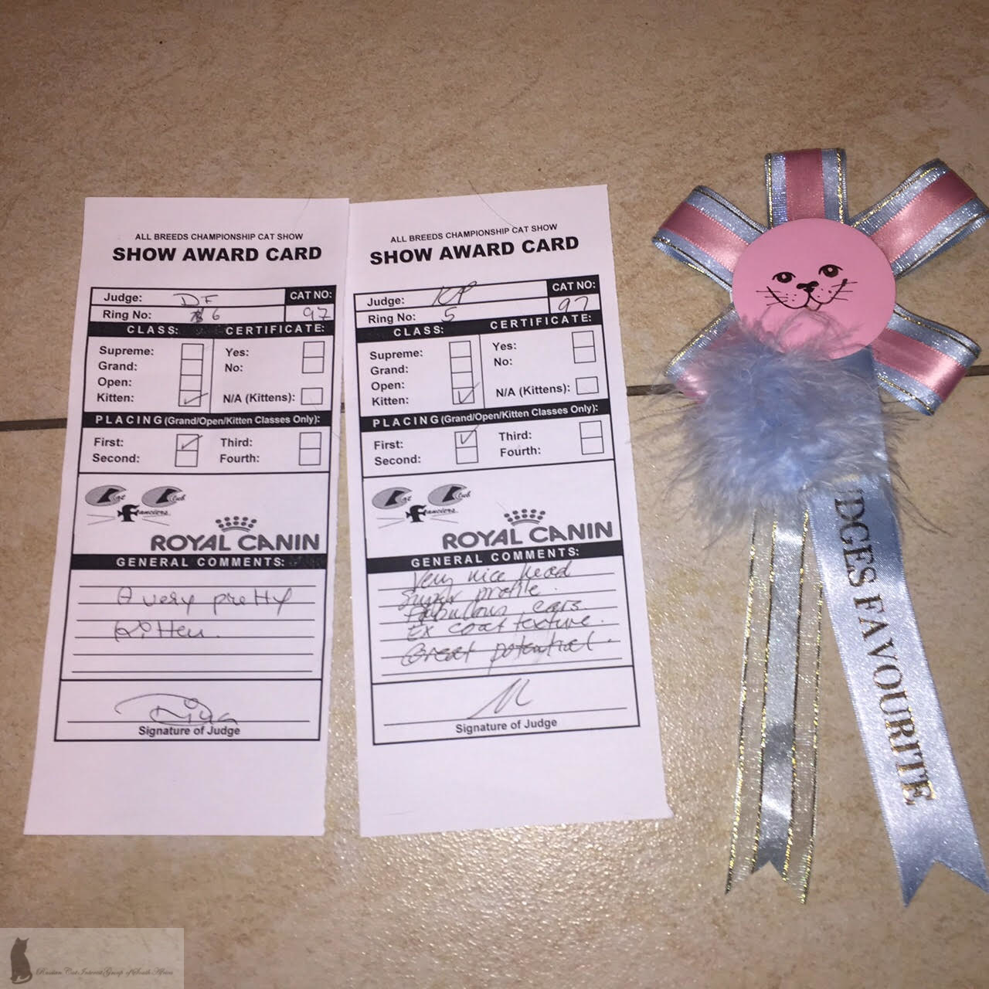

**RCIG NEWS**

**Hello all RCIG Members,**

**So since we are in the middle of our winter in the southern hemisphere, it’s a good time for a hot cuppa, whilst reading this winter edition of our newsletter and at the same time welcoming all our new Russian kitten owners and RCIG members. We hope your Russians will give you all much joy!**

**Time has really flown and the last of the 2014/2015 litters have gone and settled in their new homes. This gives our breeders and brood queens some time to recoup and rest before the 2015/2016 mating season kicks off in August.**

**As mentioned in our last newsletter, the female cats get a break from pregnancies, birthing and raising young in the winter months, as many of them go back onto the show benches in Gauteng, Cape Town and Durban.**

**We hope to see many Russians and of course the 2014/2015 Russian kittens on show this winter as well, not only in the Cape, but also in Gauteng, KwaZulu Natal, and the Southern Cape etc.**

**If you own a blue, white or black regal cat, with green eyes, large ears, long legs and tail – please show your Russians…….**

Russians Rule!

**June 2014**

**ISSUE 6**

**This was Brie’s very first kitten show,**

1. ***Brie’s first report card says:- “A very pretty kitten”.***
2. ***Brie’s second report says:- “Very nice head, super profile, fabulous ears, excellent coat texture. Great potential.” And she was awarded a Judges Favourite Rosette.***

**These two reports are incredible for such a very young baby and she WILL do great things on show as she develops just like her brother Bagheera.**

**Her litter brother Bagheera did even better on show the following day, which was his fist show ever. He was nominated in the Top 10 Kittens overall and was selected 5th Best Kitten on Show, and in the side classes, 2nd Best Foreign Kitten – Head Type, and 2nd Best Foreign Kitten – Body, Legs & Tail.**

**At just a little over four months of age, these awards and reports are a very big deal for the Russians.**

**It is common that the Russian male cats do better on show than their female counterparts. The boys show off more, they look more impressive, they are larger and their features are usually better. The females are smaller, their features are finer and more delicate than the boys and they also tend to be somewhat more pedantic in their ways than the boys are.**

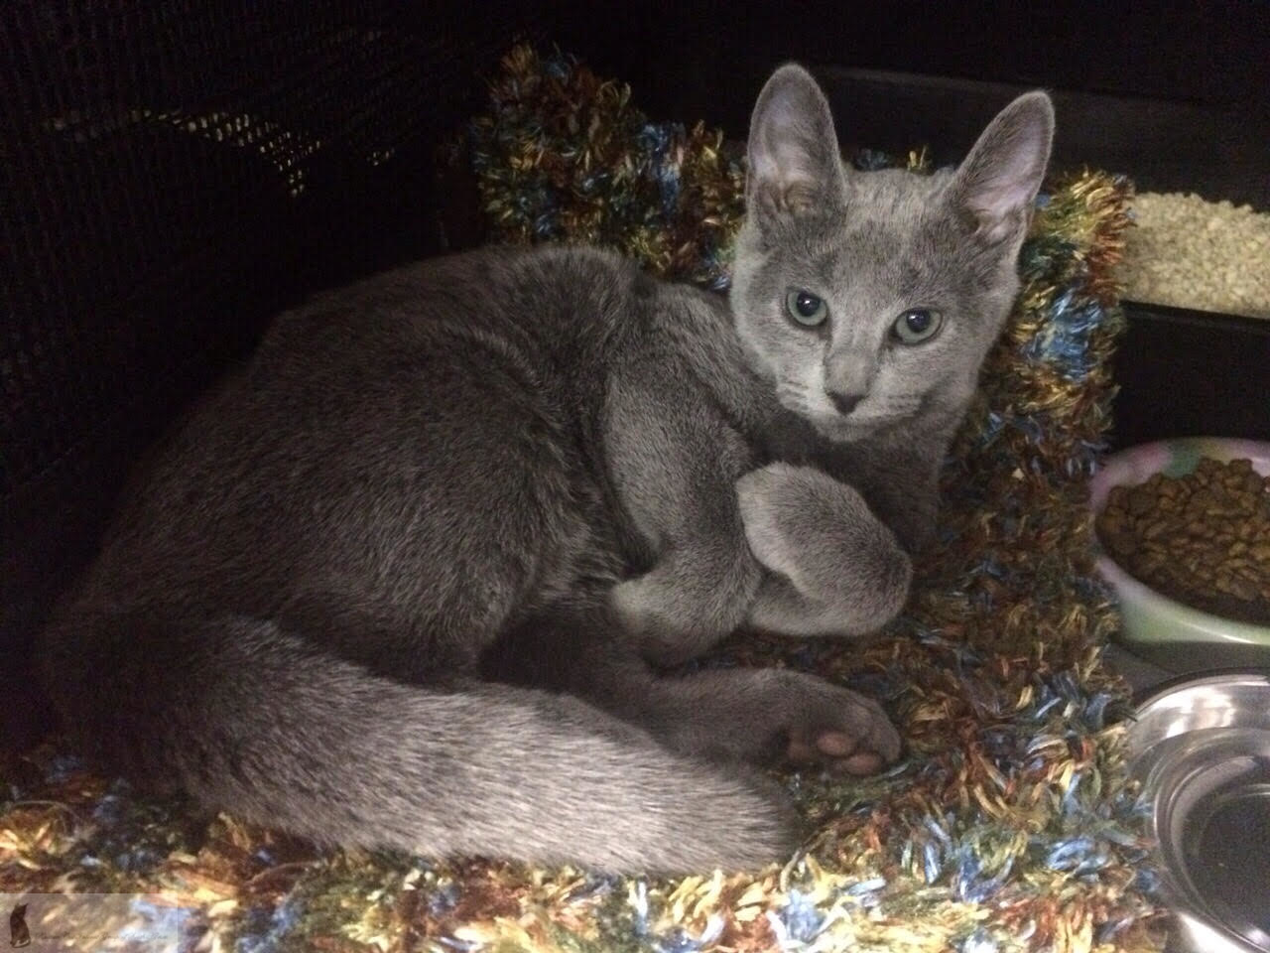

***Azreal Ballerina Brienne***

**Thank you Vanessa and Brie you made us so proud. #RussiansRule!!!!!!!**

**The Russians Exhibition Stand was voted best stand on show**

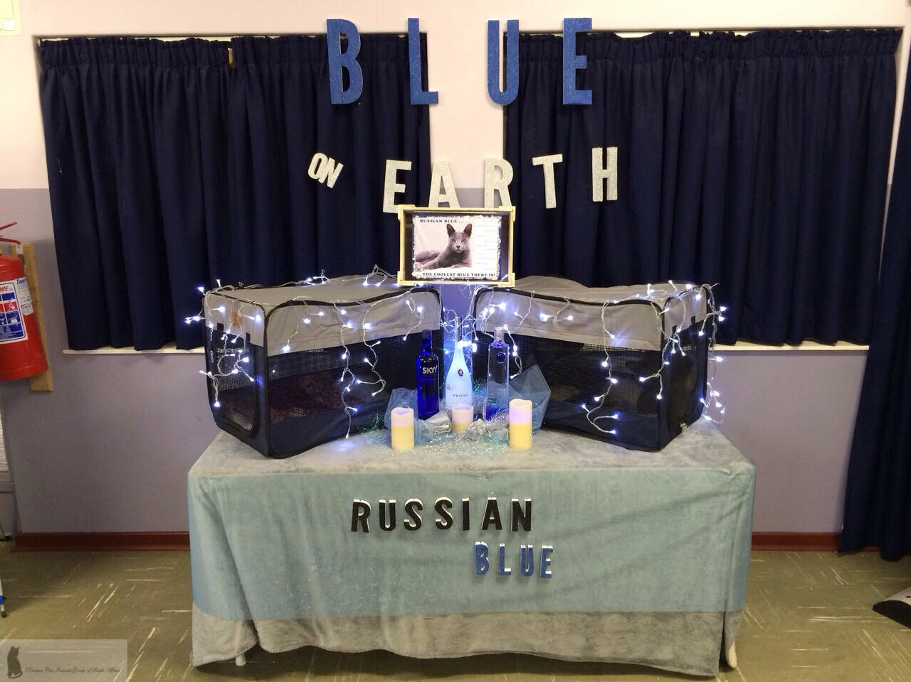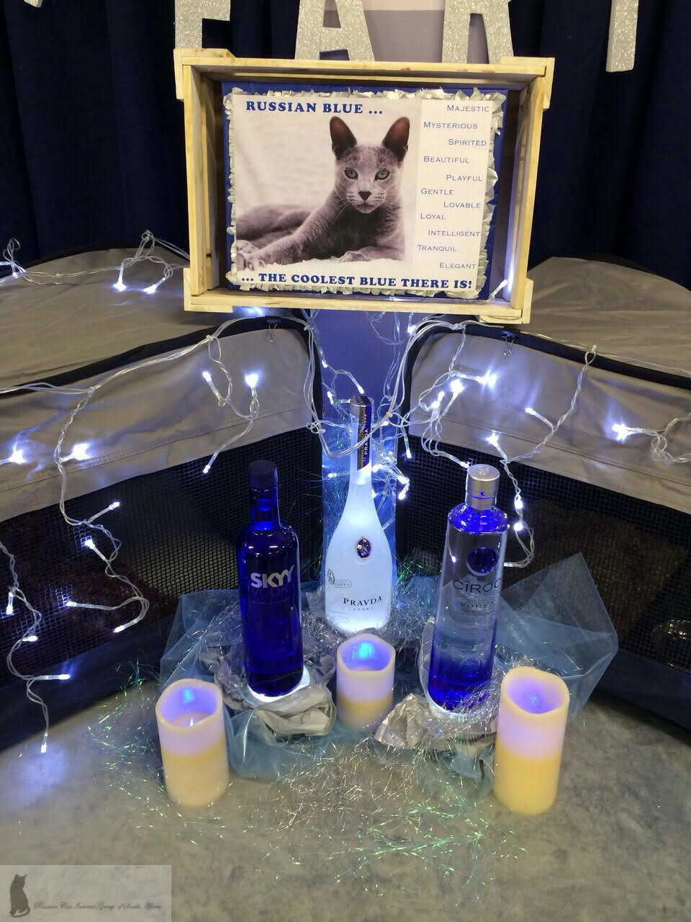

**Congratulations on your outstanding effort please pass the Vodka ☺**

Russian Blue - Russian Black - Russian White Russian Blue Spotted Tabby

!



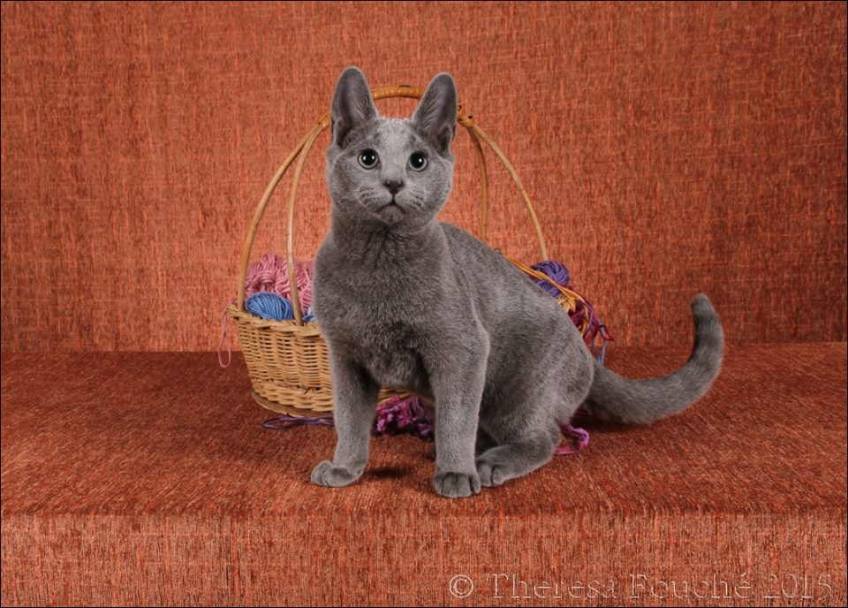

***Azreal Bagheera Bicenon – CFC Show***

***Melissa Wood is Bagheera’s slave, Bagheera was chosen by Leanne to be placed into a future cat show home. Melissa, thank you so much for making the effort to show this spectacular Russian. We wish Bagheera a very very successful show career. Nothing should stop this little guy from becoming a Sp Pr by the end of 2016.***

**Show Cat Titles**

**For those who are still new to the cat fancy, cats over the age of 9 months are awarded titles, should they conform to their breed’s Standard of Points.**

**The first title is:-**

**Champion (Ch) -for a Stud or a Queen**

**Premier (Pr) - for a Neuter or a Spay**

**Second title is:-**

**Grand Champion (Gr Ch) – for a Stud or a Queen**

**Grand Premier (Gr Pr) – for a Neuter or a Spay**

**Third title is:-**

**Supreme Champion (Sp Ch) - for a Stud or a Queen**

**Supreme Premier (Sp Pr) – for a Neuter or Spay**

**If the cats continue to be put on show after their Supreme Title change, the can go onto:-**

**Double Supreme and then eventually Triple Supreme.**

***We will continue with this in our next Newsletter.***

**Pictures by Theresa Fouche**

**Theresa Fouche is the very talented, passionate and well respected Gauteng Show Cat Photographer. Photography is Theresa’s chosen hobby in her private time, but during the week she is a very hard working woman in the IT industry.**

**Theresa has been involved in the cat fancy for many years, has cats of her own, 7 Munchkins and 1 Birman. Theresa used to breed and show, and although she loves all cats, her breed of preference is the Munchkin.**

**So if ever you see Theresa at cat shows, it will no doubt be with a camera around her neck, thus, be helpful and kind, offer her food and wine and offer to fetch and carry cats.**

**Theresa is also the talent behind the Cat of the Year slide presentation at the Glitzy Gala Affair, after the prestigious day show, at which SACC announces Cat of the Year.**

**Adding these two Russian pictures here, with the permission of Theresa. Thank you Theresa!**

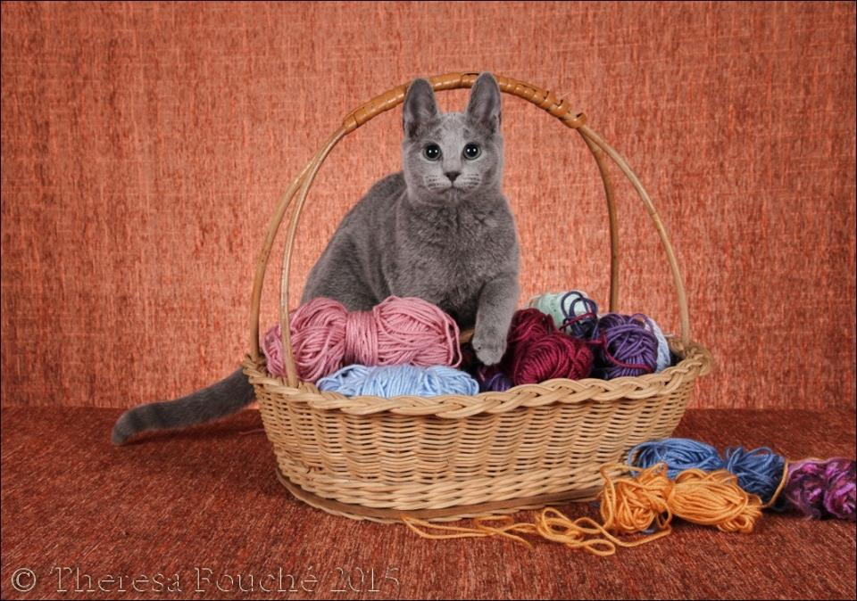

***Azreal Ballerina Brienne – CFC Show***

***Vanessa & Cyril Howell are Brie’s slaves and Brie was chosen by Leanne for Vanessa as a future Brood Queen. We wish Brie well on the show bench as well as a Brood Queen next year.***

All Russian’s are Neutered/Spayed, Vaccinated and Micro-chipped before they go to their new Pet Home…….



**Boo**

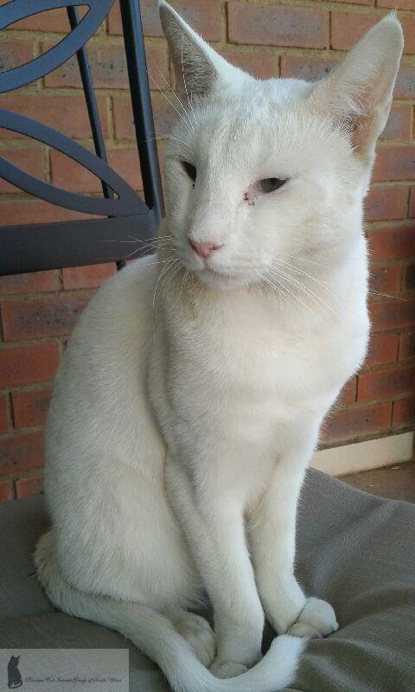

***Esky Boo***

**Boo is a 4 year old Russian White ex stud, who was bred by Alma Pretorius of Esky Russians. Boo was uneasy around other males and was rehomed with his female friend Jade in the beginning of last year. Their owners had to move and with complexes not allowing people to own pets, Boo and Jade had to go back to Alma.**

**Tristan Voss from Cape Town fell for lovely Boo and enquired whether he could adopt Boo. In April Boo joined Tristan and Nishka, but unfortunately Tristan was very very allergic to Boo and had to find him another suitable home.**

**At the time I was in Germany and could not facilitate anything whatsoever or provide Tristan any help. On my return I got into contact with Tristan and for all I know, Boo was in a new home. Tristan found the perfect person and perfect home for the White Prince.**

***……….continuation Boo***

**Lisa Grobler a Cape Town resident opened her heart, home and wrapped Boo up in her arms. All the formalities are now taken care of, Boo has been registered into Lisa’s name and he has settled in with Lisa so well. He sleeps on his white silk cushion and showers Lisa with pure Russian White LOVE!**

**Thank you once again Lisa for giving Boo a home.**

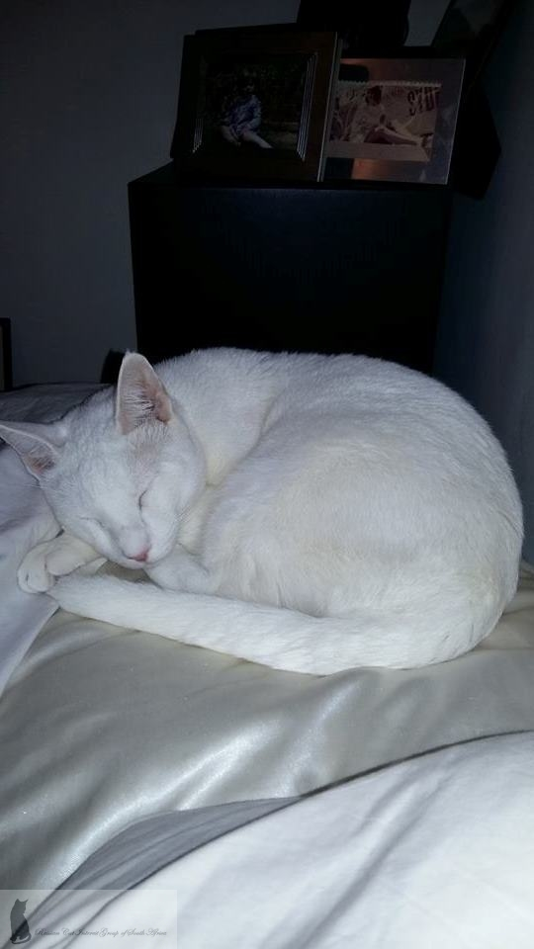

***Esky Boo in his new home***

Russians Rule………..



**Abby – A Year on with Janette…**

**Meow everyone, Abby here; I would like to give an update of my first year and 2 months with my new mom and dad.**

**I arrived in spectacular style at my new residence on the 12th April 2014. The minute my first mom Leanne let me out of my carrier, I owned the joint and was very confident – not at all scared like Neo was ;-) Speaking of him, it was a joy to be reunited with him again. He took great pride in showing me round the home as well as taking me upstairs to show me where the all-important food is kept ;-) That boy lives for his food and sleep I swear!**

**My human parents are lovely and my mom lets me get away with murder even though she says “Abby do not sit on the table, leave Neo alone, he wants to sleep or my favourite, come inside now, enough garden time” I never obey that last command. I love sitting on the wall watching the world go by too much ;-)**

**My 15 months have been amazing. I was featured in a local magazine with my mom, won the September Cat of the Month in the KittyKat magazine, appeared at two cat shows and I even found a fledgling and alerted mom to it so she could take it to Dr Kitley to be saved.**

**Good Friday this year we got another surprise in the form of a new edition to the family she goes by the name of Banana, but I was not too sure about this new cat on the block. Neo immediately made friends and took to her, I on the other hand was not to keen and there was a lot of hissing from my part! Mom said to stop it as this is a friend for me and someone to play with. I still rule the roost and will let the newbie know who is in charge from time to time ;-)**

***……….. continuation Abby***

**My new life has been absolutely fabulous to say the least. I am spoilt beyond belief, loved to the moon and back and have met some new people when mom gets visitors.**

**Thank you first mom Leanne for placing me where I am I have the best of both worlds that first started off with you.**

**Lots of love Abby**

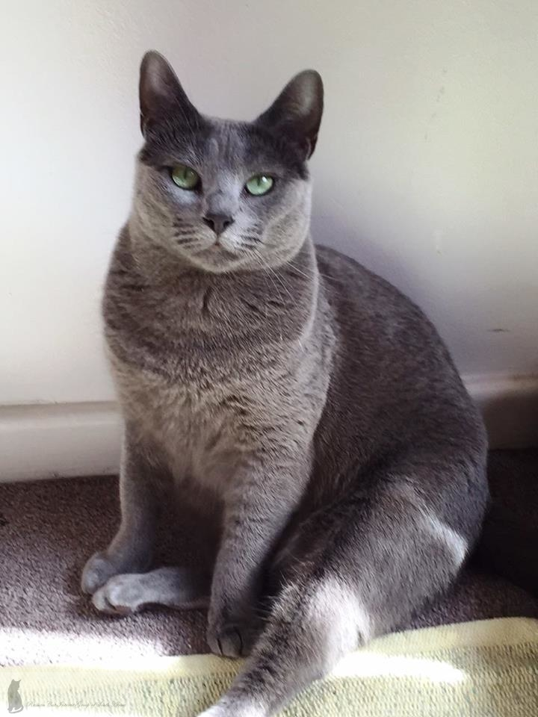

***Azreal Faberge in her new home***

***Thank you for the article and picture Janet.***

Russians need to be LOVED………..



**The Age Old Question…. – how old is my cat?**

The below table should give you your answer.

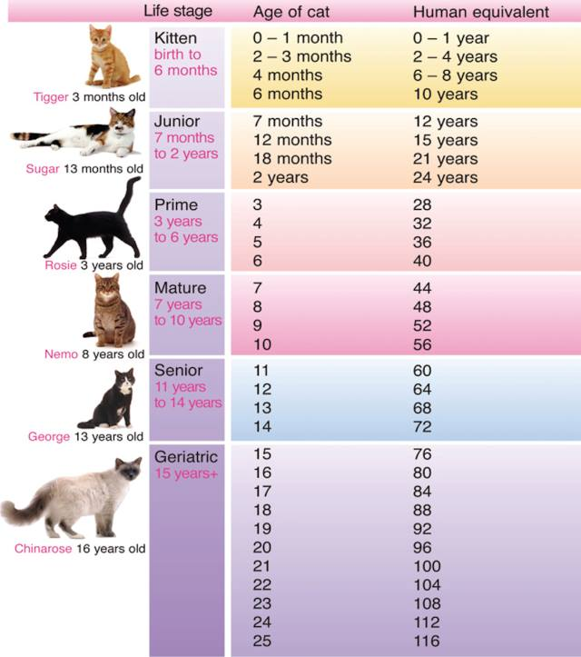

**Supplements for your Cats**

**To keep you kitty healthy at all times, mix some Protexin into their food. You can purchase this at the vet or a good vet shop. Protexin is a probiotic and keeps the gut healthy. Read the instructions on the pamphlet on dosage for cats, if you own dogs you can give them some too.**

**For added support, you can also mix some Moducare into your kitties’ food along with the Protexin, half a small capsule on a daily basis is enough. Moducare is an Immune Support Supplement which one can buy at Dischem or any other good pharmacy.**

**Cold pressed raw coconut oil is an excellent product too. Also keeps teeth healthy and fights acid, bacteria and skin conditions. Start them off early in life to get them used to these products in their diet.**

**Happy Re-homing for Kobie**

**In April this year I was approached by Caz, a lady from Natal, who wanted to adopt a Russian as one of her friends in Johannesburg had the great fortune of being able to adopt a Russian girl from a pet owner who could no longer keep her due to moving into a new place.**

**Unfortunately Russians don’t come up for adoption often and as such I suggested that she should keep an eye out for a Grey Domestic Shorthair cat/kitten. A little while later, I saw a GDS kitten on social media making its rounds and enquired whether the kitten is still looking for a home and in deed he was. Kobie was trapped as a feral kitten at Wits University but his rescuers and foster believe that he was dumped there, as he was too tame to be a feral.**

**Lynette from Johannesburg and Caz in Natal were put into contact with one other, and after seeing pictures of the kitten, Caz was smitten and in love.**

**Carol Wood, thank you for spending some time visiting Caz, to do a home check. Little Kobie now has a loving home with Caz. Thank you Caz, for this pic.**

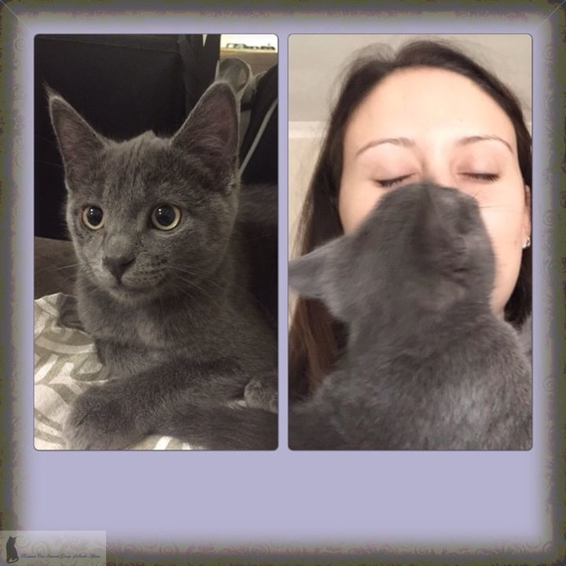

***Kobie a rescue kitten with his new mom Caz***

***This kitten was taken care of by Lynette Nicholson who deals with many fosters, raises, cares and facilitates medical care and rehomes kittens and cats to their new forever homes.***

***Thank you Lynette, Caz & Carol***

Russians keep you entertained.……..



**Cat Humour**

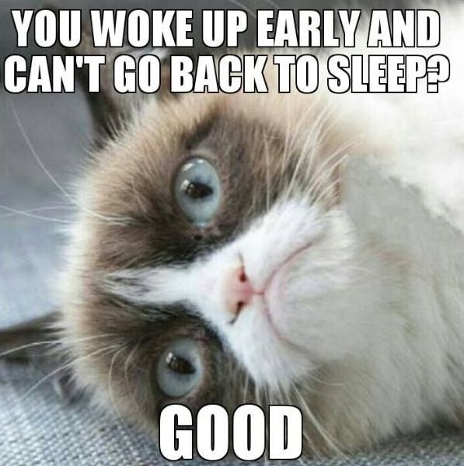

**Picture watermarks**

***NB. I would like to make each of you aware that I have decided to put a RCIG Logo watermark onto all pictures that we use in our Newsletters going forward. The watermarks don’t suggest that the images were photographed by me, but rather by the RCIG members and breeders. We need to protect the images of your Russians or other kitties, from scammers using them as their own.***

***Please feel free to add your own watermarks to your images in future…………https://www.watermark.ws/***

**Our Newsletter is made available every February, June and October, by e-mail, Facebook and Issuu.com -x-**

**RCIG Committee Members**



**Our committee members & breeders are as follows:-**

**Alma Pretorius (Esky Russians)**

[**almapretorius@gmail.com**](mailto:almapretorius@gmail.com)

**Carol Wood (Silversheen Russians)**

[**silversheenc@gmail.com**](mailto:silversheenc@gmail.com)

**Krystle Callaghan (Kriss Cross Orientals & Russians)**

[**krystle@krisscross.co.za**](mailto:krystle@krisscross.co.za)

**Laurelle Abnett (RCIG)**

[**lmabnett@iafrica.com**](mailto:lmabnett@iafrica.com)

**Leanne Hewitt (Azreal Russians)**

**Justin Hewitt (Azreal Russians)**

[**leanne@perform.co.za**](mailto:leanne@perform.co.za)

**Chris Vet (Ruskia Russians)**

**Saskia Vet (Ruskia Russians)**

[**sask@webmail.co.za**](mailto:sask@webmail.co.za)

**Solveig Klahr (RCIG)**

[**solveig.rcig@gmail.com**](mailto:solveig.rcig@gmail.com)

**Should you wish to contact us, please do not hesitate.**

**Regards your RCIG Team**

Russians make good babysitters………..

Russians own you – You are their slave…..

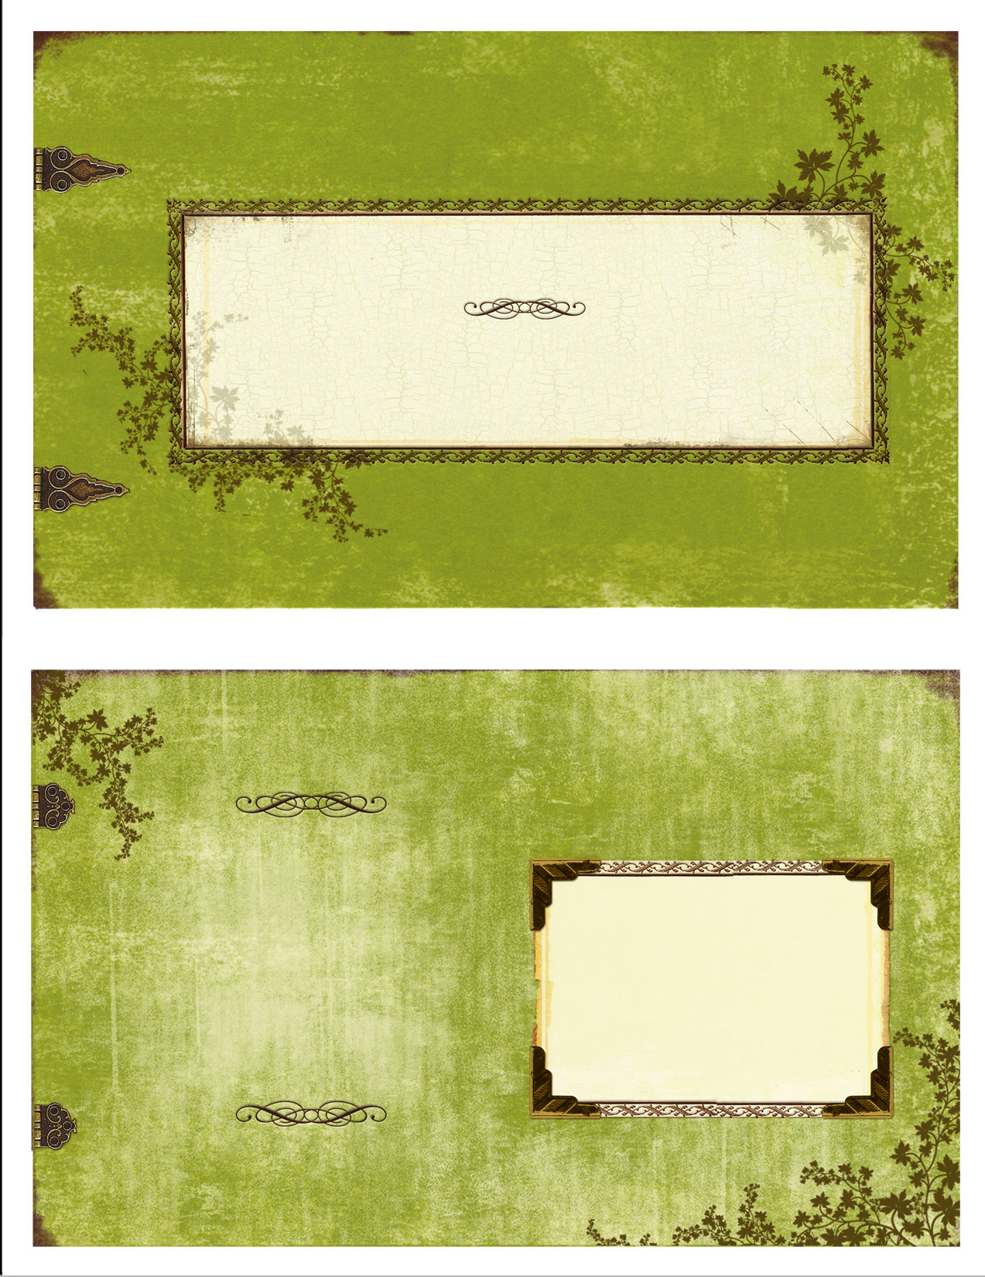



**Editor Solveig Klahr**

**083 272 2443**

[**solveig.rcig@gmail.com**](mailto:solveig.rcig@gmail.com)

For Russian Cat Interest Group Members, follow us on Facebook

[**https://www.facebook.com/groups/RCIGroup/**](https://www.facebook.com/groups/RCIGroup/)

**Or on the Web**

[**http://rcig.weebly.com**](http://rcig.weebly.com)

**https://www.facebook.com/groups/russiansrule/**

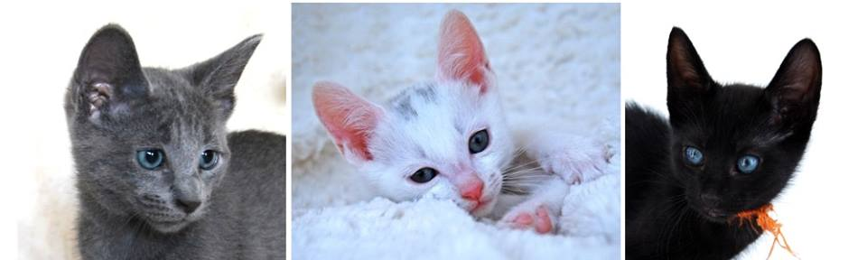

***Before you purchase a pedigree kitten/cat, please spend time researching the breed and make sure that you approach an Ethical, Reputable & Responsible Breeder. Purchase cat magazines, visit the website*** [***http://www.kittensandcats.co.za/***](http://www.kittensandcats.co.za/) ***and see who the registered breeders are or call the SACC Registrar Johan van Rooyen to find out who the Ethical breeders are. 011 616 7017-*** [***http://www.tsacc.org.za/***](http://www.tsacc.org.za/) ***Please ask as many questions as you can possibly think of when dealing with the breeder of your chosen breed. We want to stand together against BYB as they breed “fruit salad” cats, harm their breeding cats, and simply don’t care about anything as long as they make money of often sick, unaltered and underage kittens.***

***Share this info with your family and friends.***